Name:

Mexico City

You will explore google earth and google arts and culture to view places in Mexico. You must fill in 4 of the following:

Where did you stop?  - Name of place | What did you see?  - Describe area or building | What did you learn?  - Information about a fact you learned
Art-

Downtown-

Ruins-

Cathedral-

Park-

You pick a spot

You pick a spot

Postcard Home :

You just finished a Mexico City trip! You need to write a friend or family member explaining what you did in Mexico City. Must be five sentences minimum. Include one fact you learned and insert a picture :

Front of Postcard: Picture goes here

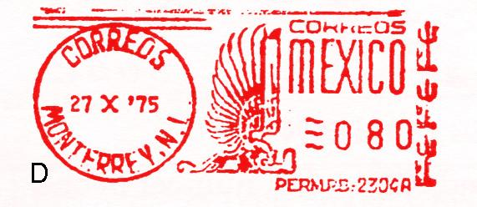
Back of Postcard: Address and Writing goes here: Create an address for who you are sending this to!
___________, ____________________________________________________________________________________________________________________________________________________________________________________________________________________________________________________________________________________________________________________________________________________________________________________________________________________  From, | Name First and Last  Street Address  City, State  Zip code

